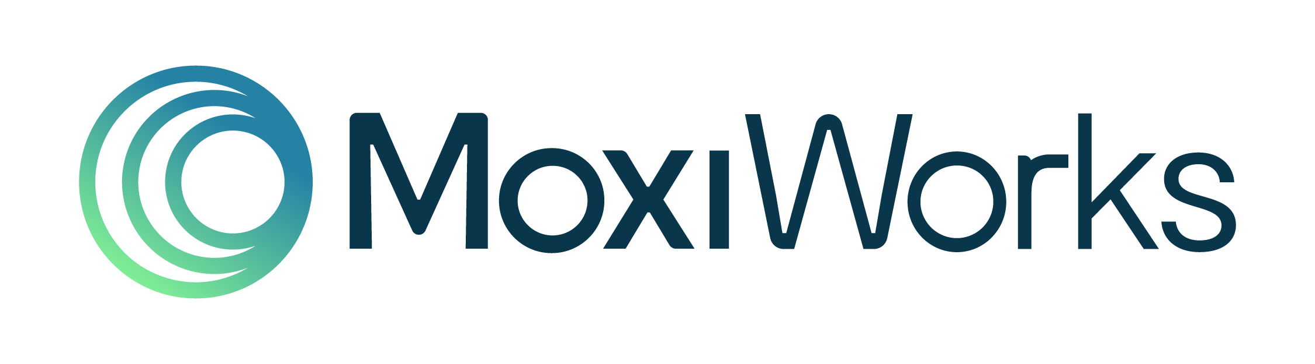

Job Title: - Software Engineer (React / React Native)
Location: Pune (Fully onsite)
Team: Engineering — Web & Mobile Platform
Employment type: Full-Time
Experience: 3-5 Years

About MoxiWorks
MoxiWorks is the leading real estate technology platform powering more than 800 brokerages and over 400,000 agents across North America. Our open platform connects CRM, marketing, websites, presentations, and transaction tools — along with a deep ecosystem of partners and MLS data sources — to help real estate professionals run their businesses end-to-end. Our Pune office plays a central role in building and scaling the integrations that move data across our platform and the wider real estate ecosystem.

About the Role
We are hiring Software Engineers (React / React Native) to join our Pune-based engineering team building the web and mobile applications that real estate professionals use every day. You will work across our React 18 + Vite web application and React Native 0.79 mobile app (iOS and Android), shipping product features end-to-end alongside senior engineers on a shared TypeScript codebase organized as a monorepo with internal packages for API clients, design tokens, and component libraries.
You will collaborate closely with product managers, designers, and global engineering teams to deliver accessible, performance-aware experiences that thousands of brokerages and hundreds of thousands of agents rely on each day.

Key Responsibilities
- Design, build, and maintain features across our React 18 web app and React Native 0.79 mobile app — components, screens, routing, state, and data layers.
- Author and consume GraphQL queries and mutations with type-safe codegen; build resilient data flows using TanStack Query for server state and Jotai (or equivalent) for client state.
- Contribute to and maintain shared monorepo packages — API/GraphQL clients, design tokens, and the web and mobile component libraries — that make future work faster and safer.
- Write clean, well-tested code with thoughtful error handling and observability; keep unit-test coverage high with Vitest / Jest / React Testing Library and contribute to integration (Cypress) and mobile E2E (Detox) suites.
- Collaborate with design via Figma → Storybook → production component flows; build accessible UI that meets Core Web Vitals on web and maintains list virtualization and re-render hygiene on mobile.
- Investigate production issues end-to-end using Bugsnag / Sentry traces, logs, and product analytics (Amplitude); drive fixes through to root cause.
- Write and maintain clear technical documentation — feature specs, component usage notes, and developer guides.
- Participate actively in code review, design discussions, sprint planning, and retrospectives.

Required Skills
- 3–5 years of professional software engineering experience, with a meaningful portion shipping TypeScript and React 18 in production.
- Hands-on React Native (0.7x+) experience, comfortable with iOS and Android native build pipelines (Xcode, Gradle, CocoaPods).
- Strong fundamentals in modern React patterns — hooks, suspense, concurrent rendering — and idiomatic TypeScript.
- Working experience with server-state libraries (TanStack Query / React Query) and at least one client-state library (Jotai, Redux, or Zustand).
- Routing experience on web (TanStack Router or React Router) and mobile (React Navigation).
- Forms with React Hook Form and schema validation (Zod or equivalent).
- Styling fluency on web (Tailwind CSS) and on mobile (StyleSheet, Unistyles, or styled approaches).
- GraphQL consumer experience — writing queries and mutations, working with codegen and typed clients.
- Solid testing discipline — Vitest / Jest / React Testing Library, plus familiarity with at least one E2E tool (Cypress, Detox, or Playwright).
- Comfort working in a monorepo (pnpm / Turborepo / Nx) with shared internal packages.
- Comfort with Git, GitHub PR workflow, CI/CD, and modern engineering practices (code review, testing, logging, monitoring).
- Strong debugging skills — you enjoy tracing a problem across the web/mobile/network boundary and reading other people's code to figure out what is really happening.
- Excellent written and verbal English; able to communicate clearly with global teammates over async and live channels.
- Bachelor's degree in Computer Science, Engineering, or equivalent practical experience.

Nice to Have
- File-based routing with TanStack Router and broader @tanstack/* ecosystem experience (Query, Table, Virtual).
- React Native new architecture, Nitro modules, Hermes, or native module bridging.
- Detox for mobile E2E and Storybook + Chromatic for visual regression.
- i18n workflows (i18next, ICU, Frontitude, or similar).
- Design-system tooling — Style Dictionary for tokens, contributions to a component library from Figma specs.
- CI/CD experience with Buildkite, CircleCI, or GitHub Actions.
- Real estate, MarTech, or CRM domain exposure.

Tech Stack
React 18, React Native 0.79, TypeScript, Vite, TanStack Router / Query / Table, Jotai, Tailwind CSS, React Native Unistyles, React Navigation, React Hook Form + Zod, GraphQL with codegen, Vitest, Cypress, Detox, Storybook, Turborepo + pnpm, Bugsnag, Amplitude, and a growing set of internal packages for building and operating our products at scale.

Benefits
- Competitive salary
- Health insurance
- Hybrid work policy

Growth Opportunities
- Work on scalable, SaaS products with real-world impact on thousands of users
- Gain hands-on experience with modern technologies, architecture, and best engineering practices
- Collaborate with cross-functional teams including Product, Design, and Customer Success
- Continuous learning through mentorship, feedback cycles, and access to learning resources

